Design Rationale: Tear-A-Way
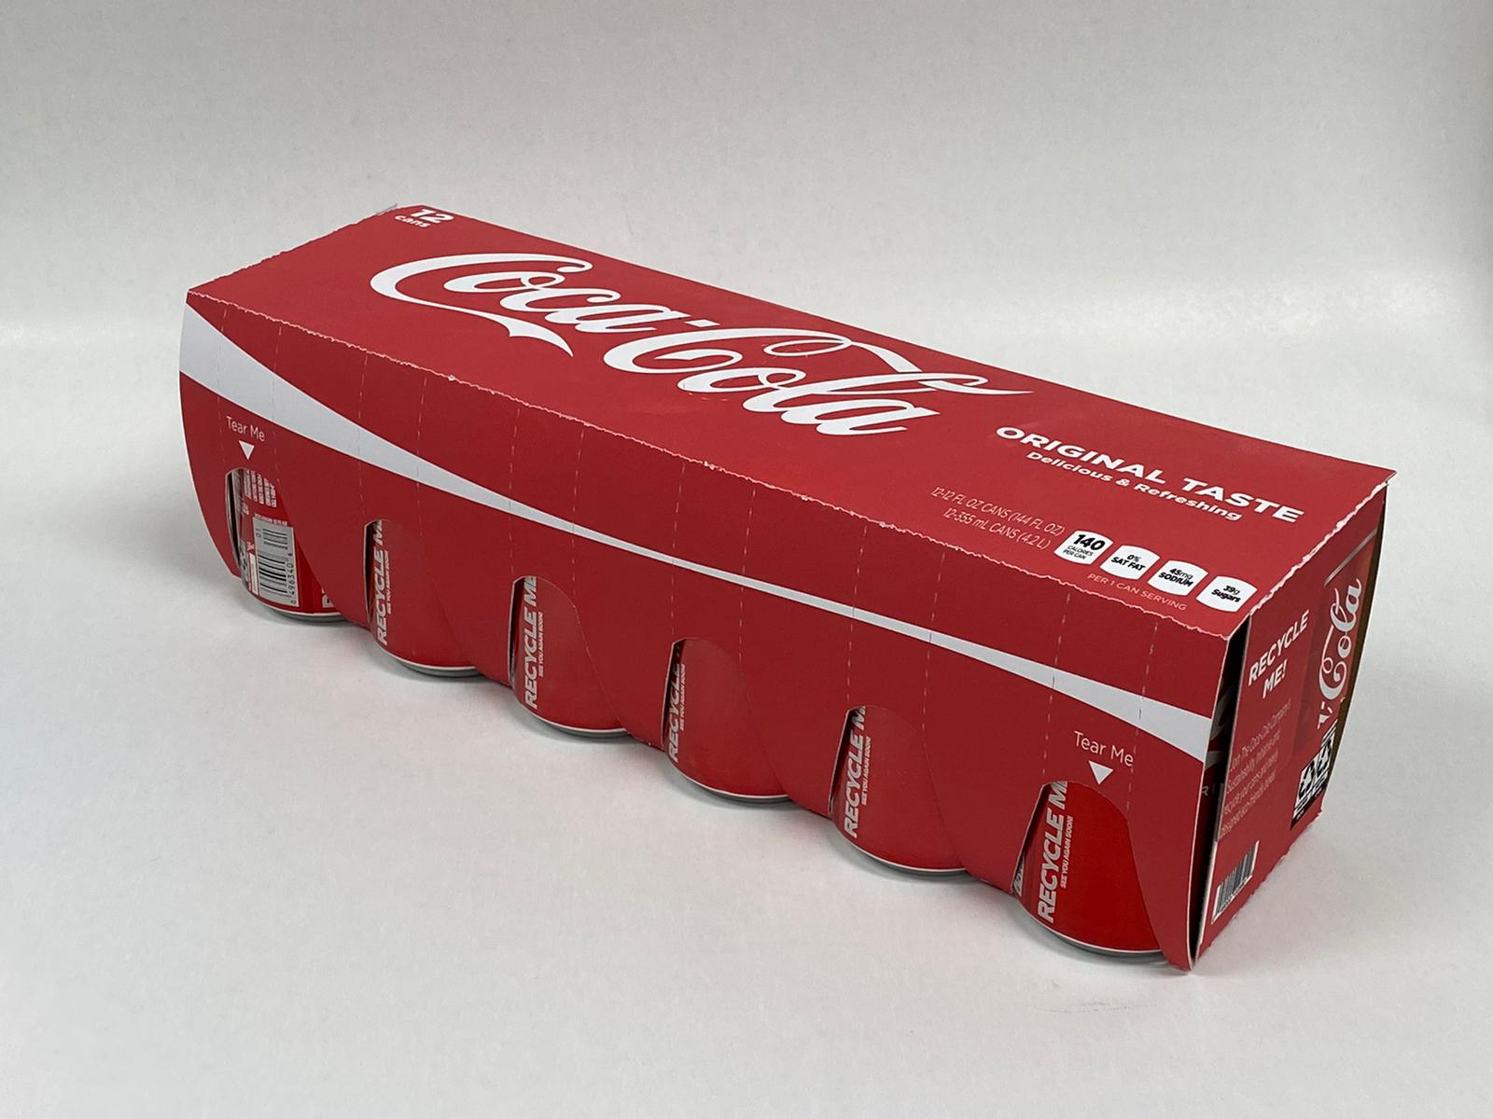
By: United Packers
(Shaneil Da Silva, Anamika Huq, Gaurav Ballal, Sarvesh Kinariwala, Syed Belal Abidi)

The Coca-Cola Company is committed to working towards a world without waste by utilizing eco-friendly packaging solutions.
In line with The Coca-Cola Company commitment, we developed the “Tear-A-Way Pack”. This new pack has two variation a 12-pack and 8-pack for the 12-ounce cans. The new package utilizes the cans to maintain the strength of the package system. By using the can, we can reduce the material by exposing the bottom quadrant of the can on either side of the package.
This method keeps the stacking ability of the system while letting the consumer visually see the how many cans are left in the package. At each opening of the can area there is a perforated strip with the text “tear me” To indicate to consumers to tear the package to get to the can.
This eco-friendly design is composed of sustainably sourced paperboard board and contains no extraneous materials, making it easier to recycle. To ensure the new style of packaging retains the classic Coca-Cola image that consumers know and love, we selected to preserve the original Coca-Cola Red and utilize the classic logo.

