Delivery Packaging Combo Program - Design Rational
Drafting Dreams Team
Ya-Su Hsieh
Conestoga College

Project Title: 7-Eleven Challenge
Objective: Ensure the product is easy to pack, safe for delivery, and user-friendly.
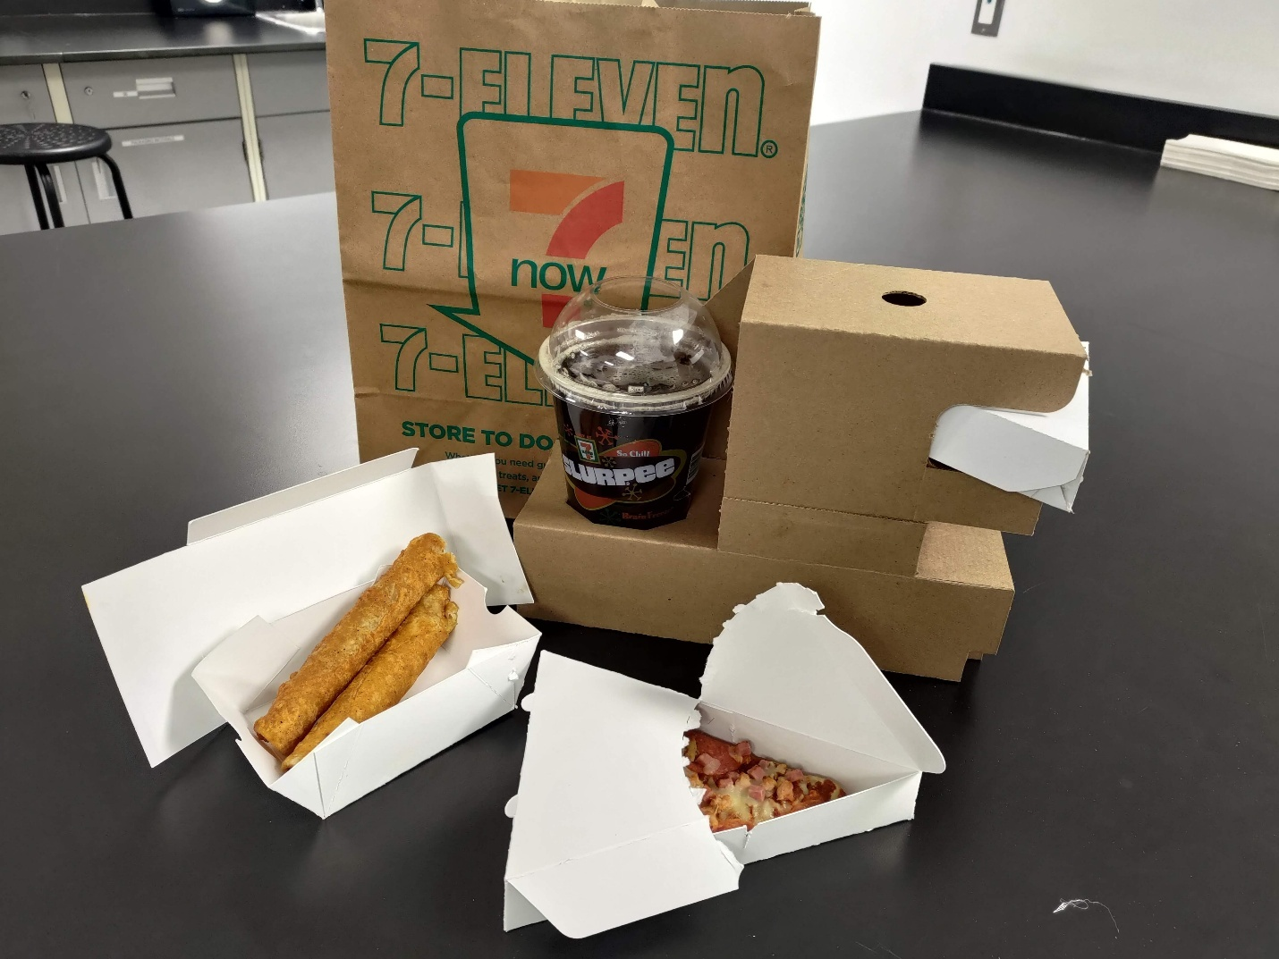
Packaging Product Strengths
Pizza Box:
- Pizza Security: Features a locking mechanism to securely lock the pizza in place.
- Mess-Free Handling: The perforation on the top and bottom allows easy peeling of the container into halves, making it easy to access your pizza without getting your hands dirty.
- Eco-Friendly: Made entirely from paperboard, eliminating plastic waste.
Food Container:
- Versatile Fit: Suitable for almost any item in 7-11 fresh food offerings, making it a universal container for various foods.
- Space-Saving Design: Can be easily collapsed to save storage space on-site.
- Convenient Handling: Easy to assemble and safe to carry.
Combo Pack for Delivery:
- Ample Space: Features three separate compartments for meals, a secure space for drinks, and additional space on top for a box of cookies.
- Drink Security: A holder at the bottom ensures drinks are delivered securely.
- Efficient Storage: Can be collapsed flat and quickly folded, maximizing space efficiency and streamlining work processes.

Conclusion
In short, our new packaging products are practical, easy to use, and good for the environment. The Pizza Box keeps pizza safe with a special lock, is easy to open without getting your hands dirty, and is made from paper, not plastic. The Food Container fits different kinds of food from 7-11, can be folded to save space, and is easy to carry. The Combo Pack for Delivery has enough room for meals, drinks, and even cookies, with a secure holder for drinks and a design that folds flat to save space and make assembly quick.
These packaging solutions show our dedication to providing high-quality, practical, and eco-friendly options for food delivery and storage. They meet our customers' needs while also helping the environment.

